GVault QDMS Post Go-Live Survey: R Notebook

#### Initialize the packages

Remove comments if you haven’t installed the packages in R yet.

# install.packages("RcURL")  
# install.packages("randomForest")   
# install.packages("e1071")  
# install.packages("caret")  
# install.packages("ggplot2")  
  
library(RCurl)

## Loading required package: bitops

library(randomForest)

## randomForest 4.6-14

## Type rfNews() to see new features/changes/bug fixes.

library(e1071)   
library(caret)

## Loading required package: lattice

## Loading required package: ggplot2

##   
## Attaching package: 'ggplot2'

## The following object is masked from 'package:randomForest':  
##   
## margin

library(ggplot2)   
set.seed(123)

Load dataset

df1<-read.csv("Gvault_survey_raw.csv",header = T)

#### Data exploration

Drop irrelevant columns

df1 = subset(df1, select = -c(Respondent.ID,Collector.ID,Start.Date,  
 End.Date,explain_training_effectiveness,explain_support,  
 explain_complete_without_help,explain_easy_access_documents,  
 explain_satisfaction,explain_Gvault_efficiency,explain_Gvault_improved, explain_office_location,explain_job_level) )  
head(df1)

## freq_use role training_instructor_led  
## 1 Daily Owner / Author Instructor Led  
## 2 At least once a week Not Sure   
## 3 Daily Reviewer / Approver Instructor Led  
## 4 At least once a month Reviewer / Approver Instructor Led  
## 5 Daily Consumer - Read Only   
## 6 Daily Reviewer / Approver Instructor Led  
## training_web_based training_read no_training  
## 1 Web/Computer Based Read & Understood of Procedural Document(s)   
## 2 Web/Computer Based Read & Understood of Procedural Document(s)   
## 3 Web/Computer Based Read & Understood of Procedural Document(s)   
## 4   
## 5 Read & Understood of Procedural Document(s)   
## 6 Web/Computer Based Read & Understood of Procedural Document(s)   
## training_effectiveness support_Gnet support_inapplication  
## 1 Effective   
## 2 Not effective enough   
## 3 Effective In-Application (GVault)  
## 4 Effective   
## 5 Not effective enough   
## 6 Effective GNet   
## support_ref_doc  
## 1 Reference Document (User Manual, Reference Guide, Training Material, etc)  
## 2 Reference Document (User Manual, Reference Guide, Training Material, etc)  
## 3 Reference Document (User Manual, Reference Guide, Training Material, etc)  
## 4   
## 5   
## 6 Reference Document (User Manual, Reference Guide, Training Material, etc)  
## support_SOP support_contacted  
## 1 SOPs and Work Instructions Contacted my Document Control or Training Group  
## 2   
## 3   
## 4 SOPs and Work Instructions   
## 5   
## 6 SOPs and Work Instructions Contacted my Document Control or Training Group  
## support_IT complete_without_help easy_access_documents satisfaction  
## 1 Most of the time Yes Satisfied  
## 2 Some of the time Yes Satisfied  
## 3 Most of the time Yes Satisfied  
## 4 Most of the time Yes Very Satisfied  
## 5 All the time Yes Very Satisfied  
## 6 Most of the time Yes Satisfied  
## Gvault_efficiency Gvault_improved  
## 1 Increased Yes  
## 2 Increased Yes  
## 3 Increased Yes  
## 4 No noticeable difference Yes  
## 5 No noticeable difference   
## 6 Increased Yes  
## functional_area explain_functional_area  
## 1 Pharmaceutical Development and Manufacturing (PDM)   
## 2 Research and Development (R&D)   
## 3 Pharmaceutical Development and Manufacturing (PDM)   
## 4 Facilities and Operations   
## 5 Research and Development (R&D)   
## 6 Pharmaceutical Development and Manufacturing (PDM)   
## office_location job_level time_worked_Glead  
## 1 Foster City Manager / Group Leader >7 Years  
## 2 Cambridge Director >7 Years  
## 3 Foster City Individual Contributor Less than a year  
## 4 Foster City Individual Contributor 1 to 2 years  
## 5 Foster City Individual Contributor Less than a year  
## 6 Alberta Manager / Group Leader >7 Years

Explore the data before fitting a model to get an idea of what to expect. I am plotting a variable on two axes and using colors to see the relationship among the levels of satisfaction. Lets explore the relationship between satisfaction and frequency of use

p=ggplot(df1,aes(x=df1$freq_use,y=df1$satisfaction,  
 color=df1$satisfaction),width=120,height=60)+  
 theme(axis.text.x = element_text(angle = 90))  
  
p + geom_jitter(alpha=0.3) +   
 scale_color_manual(breaks = c('Satisfied','Very Unsatisfied','Very Satisfied','Slightly Unsatisfied'),  
 values=c('darkgreen','red','blue','yellow'))

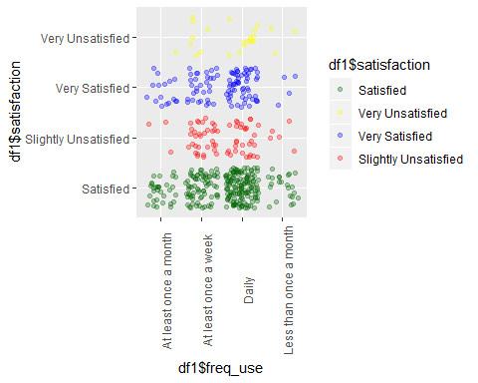

A comparison of Frequency of use (freq_use) & effectiveness of training to satisfaction shows us: Users who used Gvault daily were more likely to be satisfied or very satisfied. I’m looking for spots where there exists an overwhelming majority of one color.

p1=ggplot(df1,aes(y=df1$freq_use,x=df1$training_effectiveness,color=df1$satisfaction),width=120,height=60)+theme(axis.text.x = element_text(angle = 90))  
p1 + geom_jitter(alpha=0.3) +   
 scale_color_manual(breaks = c('Satisfied','Very Unsatisfied','Very Satisfied','Slightly Unsatisfied'),  
 values=c('darkgreen','red','blue','yellow'))

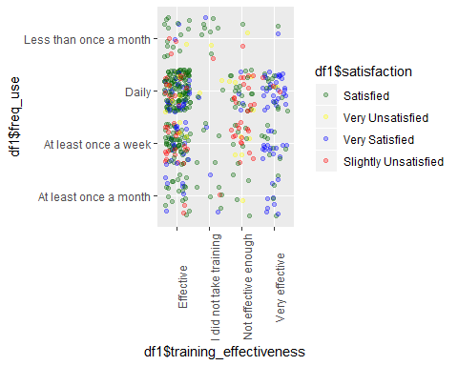

A comparison of role and the rate of completing work without help in terms likelihood of satisfaction show that: Reveiwer/Approver role users completed work in Gvault without help all the time and were more likely to be satisfied

p1=ggplot(df1,aes(x=df1$role,y=df1$complete_without_help,  
color=df1$satisfaction),width=120,height=60)+theme(axis.text.x = element_text(angle = 90))  
p1 + geom_jitter(alpha=0.3) +   
 scale_color_manual(breaks = c('Satisfied','Very Unsatisfied','Very Satisfied','Slightly Unsatisfied'),  
 values=c('darkgreen','red','blue','yellow'))

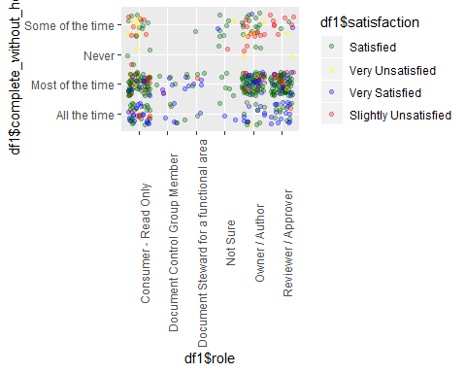

#### Train test split

Create data for training

sample.ind = sample(2,nrow(df1),replace = T,prob = c(0.9,0.1))  
data.dev = df1[sample.ind==1,]   
data.val = df1[sample.ind==2,]

I wanted to know the split of satisfaction levels in the data set and compare it between the training and test data.

# Original Data  
table(df1$satisfaction)/nrow(df1)

##   
## Satisfied Slightly Unsatisfied Very Satisfied   
## 0.56842105 0.14947368 0.23157895   
## Very Unsatisfied   
## 0.05052632

# Training Data  
table(data.dev$satisfaction)/nrow(data.dev)

##   
## Satisfied Slightly Unsatisfied Very Satisfied   
## 0.56206089 0.16159251 0.22716628   
## Very Unsatisfied   
## 0.04918033

# Testing Data  
table(data.val$satisfaction)/nrow(data.val)

##   
## Satisfied Slightly Unsatisfied Very Satisfied   
## 0.62500000 0.04166667 0.27083333   
## Very Unsatisfied   
## 0.06250000

#### Model Training: Fit Random Forest Model

I finally fit the random forest model to the training data. Plotting the model shows us that after about 20 trees, not much changes in terms of error. It fluctuates a bit but not to a large degree.

rf = randomForest(satisfaction ~ .,ntree = 100,data = data.dev)  
plot(rf)

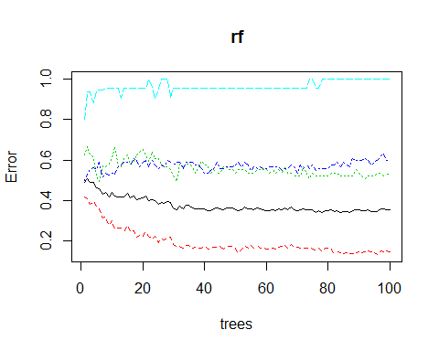

#### Feature selection: Variable Importance

Training effectiveness is the most important variable in terms of “Mean Decreasing Gini” – a similar term for information gain.

varImpPlot(rf, sort = T, n.var=10,main="Top 10 - Variable Importance")

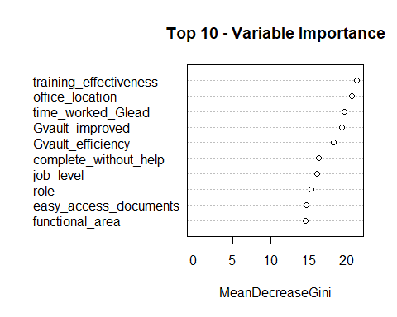

var.imp = data.frame(importance(rf, type=2))  
# make row names as columns  
var.imp$Variables = row.names(var.imp)   
print(var.imp[order(var.imp$MeanDecreaseGini,decreasing = T),])

## MeanDecreaseGini Variables  
## training_effectiveness 21.285491 training_effectiveness  
## office_location 20.574519 office_location  
## time_worked_Glead 19.654643 time_worked_Glead  
## Gvault_improved 19.349842 Gvault_improved  
## Gvault_efficiency 18.195220 Gvault_efficiency  
## complete_without_help 16.239664 complete_without_help  
## job_level 16.090225 job_level  
## role 15.298479 role  
## easy_access_documents 14.628286 easy_access_documents  
## functional_area 14.518986 functional_area  
## freq_use 12.622863 freq_use  
## support_ref_doc 6.735509 support_ref_doc  
## support_inapplication 6.655658 support_inapplication  
## support_Gnet 6.396340 support_Gnet  
## support_SOP 6.385338 support_SOP  
## support_contacted 6.127248 support_contacted  
## training_instructor_led 5.917755 training_instructor_led  
## training_read 5.645961 training_read  
## training_web_based 5.619668 training_web_based  
## explain_functional_area 3.812994 explain_functional_area  
## support_IT 3.025611 support_IT  
## no_training 1.363020 no_training

#### Prediction and Model Evaluation

I decided to use the model to attempt to predict the satisfaction level based off of the training data set. It predicted the response variable perfectly – having zero false positives or false negatives.

# Predicting response variable  
data.dev$predicted.response = predict(rf , data.dev)  
  
# Create Confusion Matrix  
print(confusionMatrix(data = data.dev$predicted.response,   
 reference = data.dev$satisfaction,  
 positive ='Very Satisfied'))

## Confusion Matrix and Statistics  
##   
## Reference  
## Prediction Satisfied Slightly Unsatisfied Very Satisfied  
## Satisfied 240 0 2  
## Slightly Unsatisfied 0 69 0  
## Very Satisfied 0 0 95  
## Very Unsatisfied 0 0 0  
## Reference  
## Prediction Very Unsatisfied  
## Satisfied 0  
## Slightly Unsatisfied 0  
## Very Satisfied 0  
## Very Unsatisfied 21  
##   
## Overall Statistics  
##   
## Accuracy : 0.9953   
## 95% CI : (0.9832, 0.9994)  
## No Information Rate : 0.5621   
## P-Value [Acc > NIR] : < 2.2e-16   
##   
## Kappa : 0.9922   
##   
## Mcnemar's Test P-Value : NA   
##   
## Statistics by Class:  
##   
## Class: Satisfied Class: Slightly Unsatisfied  
## Sensitivity 1.0000 1.0000  
## Specificity 0.9893 1.0000  
## Pos Pred Value 0.9917 1.0000  
## Neg Pred Value 1.0000 1.0000  
## Prevalence 0.5621 0.1616  
## Detection Rate 0.5621 0.1616  
## Detection Prevalence 0.5667 0.1616  
## Balanced Accuracy 0.9947 1.0000  
## Class: Very Satisfied Class: Very Unsatisfied  
## Sensitivity 0.9794 1.00000  
## Specificity 1.0000 1.00000  
## Pos Pred Value 1.0000 1.00000  
## Neg Pred Value 0.9940 1.00000  
## Prevalence 0.2272 0.04918  
## Detection Rate 0.2225 0.04918  
## Detection Prevalence 0.2225 0.04918  
## Balanced Accuracy 0.9897 1.00000

#### Model Testing

Now it was time to see how the model did with data it had not seen before– making predictions on the test data.

# Predicting response variable  
data.val$predicted.response <- predict(rf ,data.val)  
  
# Create Confusion Matrix  
print(confusionMatrix(data=data.val$predicted.response,   
 reference=data.val$satisfaction,  
 positive='Very Satisfied'))

## Confusion Matrix and Statistics  
##   
## Reference  
## Prediction Satisfied Slightly Unsatisfied Very Satisfied  
## Satisfied 26 1 8  
## Slightly Unsatisfied 3 1 0  
## Very Satisfied 1 0 5  
## Very Unsatisfied 0 0 0  
## Reference  
## Prediction Very Unsatisfied  
## Satisfied 0  
## Slightly Unsatisfied 3  
## Very Satisfied 0  
## Very Unsatisfied 0  
##   
## Overall Statistics  
##   
## Accuracy : 0.6667   
## 95% CI : (0.5159, 0.796)  
## No Information Rate : 0.625   
## P-Value [Acc > NIR] : 0.3313   
##   
## Kappa : 0.3391   
##   
## Mcnemar's Test P-Value : NA   
##   
## Statistics by Class:  
##   
## Class: Satisfied Class: Slightly Unsatisfied  
## Sensitivity 0.8667 0.50000  
## Specificity 0.5000 0.86957  
## Pos Pred Value 0.7429 0.14286  
## Neg Pred Value 0.6923 0.97561  
## Prevalence 0.6250 0.04167  
## Detection Rate 0.5417 0.02083  
## Detection Prevalence 0.7292 0.14583  
## Balanced Accuracy 0.6833 0.68478  
## Class: Very Satisfied Class: Very Unsatisfied  
## Sensitivity 0.3846 0.0000  
## Specificity 0.9714 1.0000  
## Pos Pred Value 0.8333 NaN  
## Neg Pred Value 0.8095 0.9375  
## Prevalence 0.2708 0.0625  
## Detection Rate 0.1042 0.0000  
## Detection Prevalence 0.1250 0.0000  
## Balanced Accuracy 0.6780 0.5000